Minutes of P&C meeting 30 October 2019

Minutes of P&C meeting 30 October 2019
- Welcome by Belinda Brodrick (chair) and apologies - Martin Brown

List of attendees- signed sheet of 11 attendees

Presentation by Allen James of the Stile program used by the science department

Showed large student useage and interactive nature of the system

2. Acceptance of last minutes

Proposer: Belinda

Seconded: Megan

3. Business arising from the Previous Minutes

Trevor Hazelwood response due back from school - in business arising

Stem award - to create a subcommittee regarding how the award would be recognised. Thanks to Leonore and Kevin for the support for this award. See business arising

4. Principals Report

Senior Lawn - 2 sections completed
Painting ongoing especially on the upper floor
Thank you to Janet re solar funding - awaiting grant application feedback
Chaplaincy program funding applied for also - 2 counsellors in the school- Linda/Amanda is full time one position and we have 2 staff providing additional support via Aggie and Steffani.
Leonore raised objection that we have outside Christian based service in school. (reach community)
Artificial lawn for science lawn - grant applied for as over $20,000 - if awarded money P&C provided could be repurposed
Investigating shade umbrellas that can fix to the ground
Debating and public speaking proposal to be initiated next year
Recruiting for Business manager - closes next week for position year
New staff appointed in Math, English/Drama job and HSIE and LAsT position to be advertised and appointed this term
Presentation of new skirt and blouse for senior uniform via Noone - during alternate week (year 10 program) in week 8 students will be fitted for either pick up from school or sent via post to home.

5. Subcommittee reports.

Fundraising - Trivia night - 20th September event - resounding success with 88 people attending. Final figure to be provided
Ticket sales $2200
Cash - $1241
Card payments of $2360.28

Some expenses to be deducted.
Final income to be advised next meeting

6. Finance committee/Treasurer's Report
Thanks to Jenny for the audit

Motion to accept expenditure of up to $500 for the trivia night
Proposer Greg
Seconded Paul
Accepted

Finance committee meeting
Stile presentation - cost of over $7000 pa presented at the finance committee meeting - deferred to next meeting and consideration of overall school priorities as cost is over $22,000 for 3 years.

Drama department - request for funding of replacement of 14 drama blocks of various for $3010.
Motion to support Greg
Seconded Rachel
Accepted

Motion for ongoing recurring expenditure of $50 for each year group award from P&C
Proposed Greg
Seconded Rachel

Motion to approve funding of graduation on recurrent basis of $2000
Proposer - Greg
Seconded - Rachel
Accepted

Report attached

7. Business Arising:

- Solar power - application sent by Janet Els-Smith coordinated for $25,000 required a $35,000 commitment from the school.
Motion to commit P&C funding should application be successful
proposed by Janet
Seconded Paul
Accepted
- Trevor Heazelwood Incentive - Clarina and Alison have written up proposal (to add in from alison/belinda)
- Shade in the Quad - area over raised section near office being investigated
- School Entrance - Columns - deferred to next meeting
- Wish list 2020 - request to Principal to return to P&C with school priorities
- Stem award - conditions/criteria for the STEM award and letter of support received from Lenore and Kevin - gratefully accepted the cheque of $150 for the award and invite to present at presentation. This is to promote STEM in the school.
- AGM on 27 November
All position will be declared vacant. Please consider nominating for the official positions as a number of executive members are not renominating.
- Lenore - suggested P&C should consider more political action in addition to fundraising
- Suggested that the school website has a list of the awards provided by the school - Alison to investigate
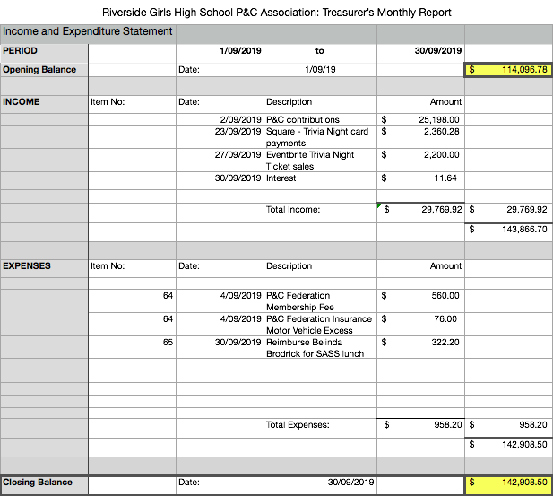

Approved Expenditure
Item No | Item | Amount Approved | Date Approved | Date Paid | Amount not yet paid | Comments | Account balance at 30/09/2019 | Available funds at 30/09/2019
32 | Stage 1 of Masterplan Design | $25,000.00 | 9/08/2017 |  | $- | 14/5/2019 Voted to return $25000 to general funds. Masterplan no longer appropriate.
33 | Refurbishment of quad | $50,000.00 | 9/08/2017 | 12/12/2018 15,000  8/2/2019 30,000  21/2/2019 5,000 | $-
36 | Year 12 graduation catering | $2,000.00 | 9/08/2017 | 4/06/2018 | $-
37 | P&C Citizen award Year 11 Hannah Sandison Cheque 200040 | $50.00 | 9/08/2017 | 2/08/2018 | $-
39 | rghspandc domain hosting | $114.00 | 9/08/2017 | 22/05/2018 | $- | Ongoing annual expense
40 | 7 x 3D printers x $1045 each | $7,315.00 | 13/09/2017 | 4/06/2018 | $-
41 | 10 STELR kits | $4,990.00 | 13/09/2017 | 4/06/2018 | $-
42 | 5 jazz arrangements | $800.00 | 13/09/2017 | 4/06/2018 | $-
43 | 3 students for Max Potential x $150 | $450.00 | 13/09/2017 | 4/06/2018 | $- | One student attended. Extra $300 to be allocated to City Country Alliance Leadership event. Carried 8/11/17
44 | 2 new marquees: BETTA | $2,748.00 | 8/11/2017 | 4/6/18 paid $1361.63. 10/8/18 paid $1361.63 | $- | 1 received at 9/4/18. Cost $1,361.63 ex GST. 2nd paid 10/8/18
45 | STILE (Cosmos) Science magazines | $2,000.00 | 13/12/2017 | 4/6/18 paid $1955 | $-
46 | LOTE Language Perfect | $5,000.00 | 13/12/2017 | 4/06/2018 | $-
47 | TAS materials for Connect | $1,000.00 | 13/12/2017 | 12/11/2018 | $-
48 | Elevate Education: Amended to support for Bell Shakespeare Co | $3,400.00 | 21/02/2018 & 15/8/18 | 12/11/2018 | $-
49 | Gelato cart & expenses for open day |  | 21/02/2018 | $1015.65 paid 26/3/18 | $-
50 | Big Ass Fan | $15,000.00 | 15/08/2018 | 12/12/2018 | $-
51 | Year 12 Graduation | $2,000.00 | 15/08/2018 | 12/11/2018 | $-
52 | P&C Award cheques 6 x $50.  Yr 12 Samantha Du Cheque 41  Yr 11 Amelia Warren Cheque 47  Yr 10 Nidhi Anugu Cheque 46  Yr 9 Jemma Barrett Cheque 45  Yr 8 Emma Lebeuf Cheque 44  Yr 7 Luka-Belle Roberts Cheque 43 | $300.00 | 15/08/2018 | Chq 41 12/3/2019  Chq 47 25/1/2019  Chq 46 13/3/2019  Chq 45 10/12/2018  Chq 44 25/3/2019  Chq 43 25/2/2019 | $-
53 | Amy Wolken Junior Volleyball State Comp Cheque 200042 | $100.00 | 12/09/2018 | 31/10/2018 | $-
54 | Two frames for musicals pictures | $1,540.00 | 12/09/2018 | 12/8/2019 $770 | $770.00 | 7/8/2019 770 Mary Poppins invoice 9000162765
55 | Trevor Heazlewood Scholarship Donation | $10,000.00 | Banked 25/10/2018 |  | $10,000.00 | To be distributed $1,000 per year for 10 years
56 | “Stile” app for Science. Proposed to be extended to years 9, 10 as well as 7, 8. | $4,000.00 | 12/12/2018 | 20/08/2019 | $-
57 | To provide $6,000 for purposes of the Wicked musical | $6,000.00 | 13/02/2019 | 20/08/2019 | $- | 13/2/2019 Pending receipt of budget  14/5/2019 budget received
58 | To fund refugee challenge $50/trainer and $5/others | $2,000.00 | 10/04/2019 | 12/08/2019 | $- | 6/8/2019 invoice 9000162766
59 | To support Word Flyers up to $5000 | $5,000.00 | 14/05/2019 | 20/08/2019 | $- | 14/5/2019 To be reviewed on receipt of final quote
60 | Costs associated with Wicked Musical fundraising including popcorn, fairy floss, drinks, lollies | $1,000.00 | 14/05/2019 | 3/6/2019 467.00 Fudge Shop  29/6/2019 100.84 Belinda  29/6/2019 451.16 Megan  Total 1019.00 | $-
61 | Boss Challenge | $3,000.00 | 14/05/2019 |  | $3,000.00 | 14/5/2019 Report of financial and evaluative outcomes to be given to P&C and any proceeds to be utitilised in consultation with P&C.
62 | Artificial Grass mats | $1,011.00 | 14/05/2019 | 12/08/2019 | $- | 7/8/2019 919 ex GST invoice 9000162764
63 | Mulching Fork for working bees | $69.00 | 14/05/2019 | 1/07/2019 | $- | Reimbursed Megan Hudson
64 | P&C federation fees | $636.00 | 4/09/2019 | 4/09/2019 |  | 31/7/2019 Email approval by Executive to just pay membership fee without optional insurance.  1/9/2019 Emailed executive to agree to pay equivalent of last year i.e. membership plus motor vehicle excess insurance
65 | SASS lunch | $322.00 | 4/09/2019 | 30/09/2019 $322.20
66 | Friends Of Riverside website, domain, SSL certificate annual costs | $168.00 |  |  | $168.00 | Haven't made any use of this with no Riverside Connect in last two years. Do we still want to continue paying for this?  Suggestion we retain domain name for $12 fee annually and retain google suite of P&C emails etc.
67 | Artificial turf near demountables | $32,250.00 | 4/09/2019 |  | $32,250.00
68 | Year 12 Graduation contribution towards catering, decorations. | $2,000.00 | 4/09/2019 |  | $2,000.00
69 | Banners for music stands | $600.00 | 4/09/2019 |  | $600.00
70 | Education Perfect - French language online program | $6,120.00 | 4/09/2019 |  | $6,120.00
71 | Senior Lawn (Kikuyu grass) | $25,802.00 | 4/09/2019 |  | $25,802.00
 |  |  |  |  | $80,710.00 |  | $142,908.50 | $62,198.50

